TAKSHASHILA UNIVERSITY

Tamil Nadu State Private University
( Established under Tamil Nadu State Private Universities Act 2019
& Recognized by UGC u/s 2(f) of the UGC Act,1956 )
Ongur, Tindivanam Taluk, Villupuram District, Tamil Nadu – 604305.



FACULTY

OF SCIENCE

S

SCHOOL OF COMPUTER SCIENCE

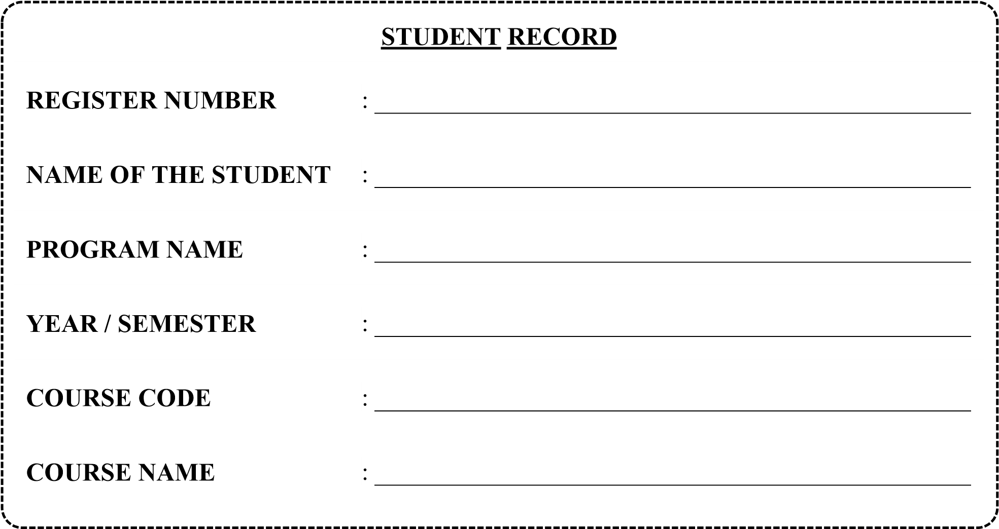

TAKSHASHILA UNIVERSITY

Tamil Nadu State Private University
( Established under Tamil Nadu State Private Universities Act 2019
& Recognized by UGC u/s 2(f) of the UGC Act,1956 )
Ongur, Tindivanam Taluk, Villupuram District, Tamil Nadu – 604305.

FACULTY OF SCIENCES

School of Computer Science
Bonafide Certificate

Register Number

This is to certify that this is a Bonafide Record of practical work done by
Mr./Ms. ……….………………………………………… of ……….………….……….……
……….………….…Semester in the ……….……….………………….….……………………
Laboratory during the academic year ……….……………………

Signature of Course Incharge Signature of School Incharge

Submitted the University Practical Examination held on ………………………….

Signature Internal Examiner Signature External Examiner

CONTENT

Ex. No | Date | Name of the exercise | Page | Signature
1 |  | Descriptive Statistics Using NumPy and Pandas
2 |  | Data Type Identification and Frequency Distribution Analysis
3 |  | Probability Fundamentals Using Python Simulation
4 |  | Random Sampling and Sample vs Population Analysis
5 |  | Normal Distribution and Z-Score Analysis
6 |  | Binomial Distribution Implementation and Analysis
7 |  | Poisson Distribution and Event Modeling
8 |  | Correlation Analysis Between Numerical Variables
9 |  | Covariance Analysis and Interpretation
10 |  | Hypothesis Testing Using Z-Test and T-Test
11 |  | Confidence Interval Estimation for Population Mean
12 |  | Univariate Exploratory Data Analysis
13 |  | Bivariate and Multivariate Exploratory Data Analysis
14 |  | Complete Exploratory Data Analysis Case Study

Ex. No: 01 | Descriptive Statistics Using NumPy and Pandas
Aim
To perform descriptive statistical analysis on the Titanic dataset using NumPy and Pandas and calculate measures such as mean, median, and standard deviation.

Procedure
- Import the required libraries (Pandas, NumPy, Matplotlib, Seaborn).
- Load the Titanic dataset using Seaborn.
- Display summary statistics using describe().
- Calculate the mean, median, and standard deviation of the Age column.
- Print the calculated statistical measures.

Program
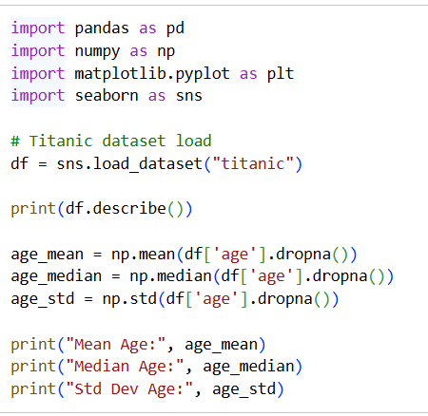

Output

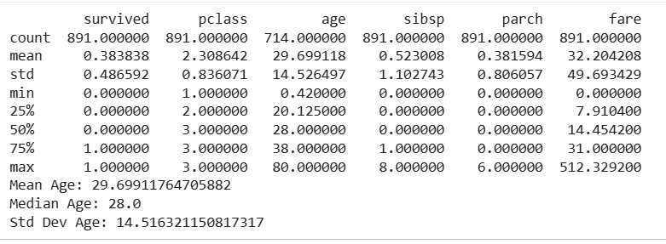

Result
The Titanic dataset was successfully analyzed using NumPy and Pandas. The mean age, median age, and standard deviation of passengers were calculated, demonstrating the use of descriptive statistics for data analysis.
Ex. No: 02 | Data Type Identification and Frequency Distribution Analysis

Aim
To identify the data types of variables in the Titanic dataset and analyze the frequency distribution of categorical features using Pandas and Seaborn.

Procedure
- Import the required libraries (Pandas, NumPy, Matplotlib, Seaborn).
- Load the Titanic dataset using Seaborn.
- Display the data types of all columns using dtypes.
- Calculate frequency distributions of categorical variables using value_counts().
- Visualize the frequency distribution of passenger classes using a count plot.
Program
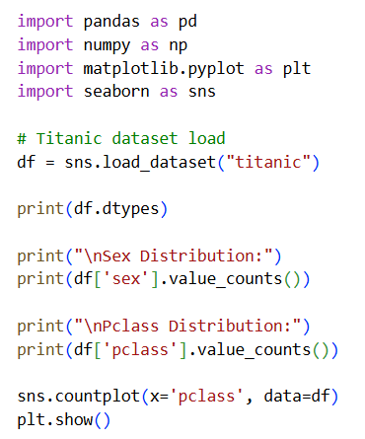

Output
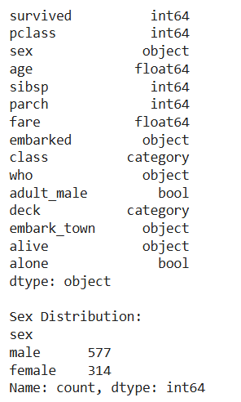
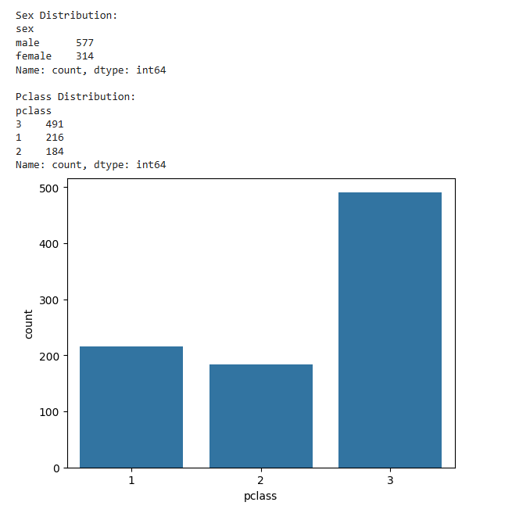
Result
The data types of all variables in the Titanic dataset were successfully identified. Frequency distributions for categorical variables were calculated and visualized, helping in understanding the structure and composition of the dataset.

Ex. No: 03 | Probability Fundamentals Using Python Simulation

Aim
To understand the concept of probability by calculating the survival probability from the Titanic dataset and verifying it through random simulation using NumPy.

Procedure
- Import the required libraries (Pandas, NumPy, Matplotlib, Seaborn).
- Load the Titanic dataset using Seaborn.
- Calculate the survival probability using the survived column.
- Simulate 1000 passenger outcomes using np.random.choice().
- Compare the simulated probability with the actual survival probability.

Program
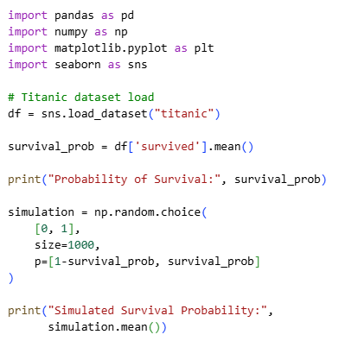
Output
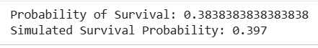
Result
The probability of survival was calculated from the Titanic dataset and verified through a random simulation. The simulated probability was found to be close to the actual survival probability, demonstrating the practical application of probability concepts using Python.
Ex. No: 04 | Random Sampling and Sample vs Population Analysis

Aim
To perform random sampling on the Titanic dataset and compare the sample mean with the population mean to understand sampling concepts.

Procedure
- Import the required libraries (Pandas, NumPy, Matplotlib, Seaborn).
- Load the Titanic dataset using Seaborn.
- Calculate the population mean of the Age column.
- Draw a random sample of 100 observations from the Age column.
- Calculate and compare the sample mean with the population mean.

Program
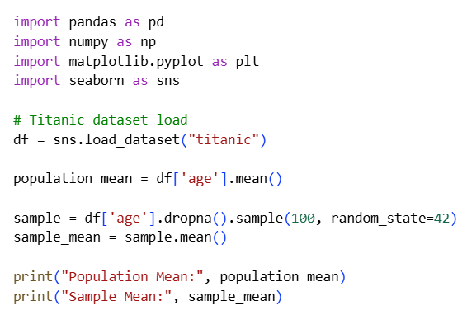
Output
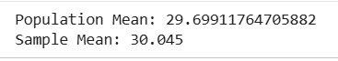
Result
A random sample was selected from the Titanic dataset, and its mean age was calculated. The sample mean was found to be close to the population mean, demonstrating that random samples can provide a good representation of the overall population.
Ex. No: 05 | Normal Distribution and Z-Score Analysis

Aim
To analyze the distribution of passenger ages in the Titanic dataset and calculate Z-scores to understand data standardization and normal distribution.

Procedure
- Import the required libraries and the zscore function from SciPy.
- Load the Titanic dataset using Seaborn.
- Handle missing values in the Age column by replacing them with the mean age.
- Calculate the Z-score for each age value.
- Display the Age and corresponding Z-scores.
- Plot a histogram with KDE to visualize the age distribution.
Program
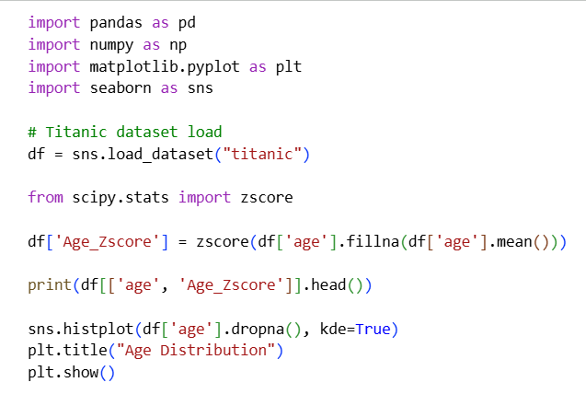

Output
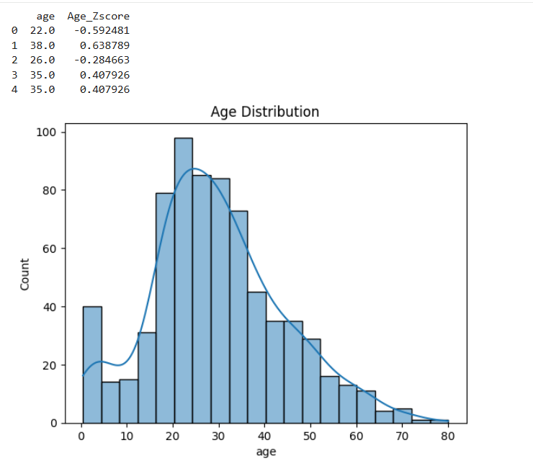
Result
The age data was standardized using Z-scores and its distribution was visualized. The histogram indicated that passenger ages approximately follow a normal distribution, and Z-scores helped measure how far each age value lies from the mean in terms of standard deviations.

Ex. No: 06 | Binomial Distribution Implementation and Analysis

Aim
To implement the Binomial Distribution using Python and calculate the probability of obtaining a specific number of survivors based on the Titanic dataset.

Procedure
- Import the required libraries and the Binomial Distribution function from SciPy.
- Load the Titanic dataset using Seaborn.
- Calculate the survival probability from the dataset.
- Define the number of trials (n = 10) and the desired number of successes (x = 5).
- Use the Binomial PMF function to calculate the probability.
- Display the calculated probability.

Program
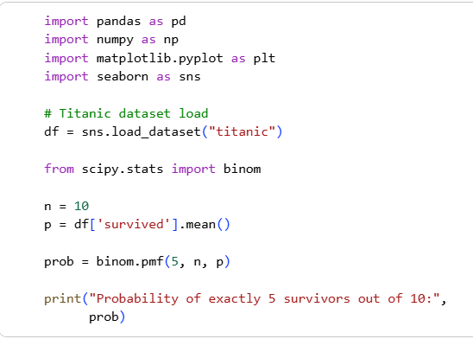
Output

Ex. No: 07 | Poisson Distribution and Event Modeling

Aim
To implement the Poisson Distribution using Python and calculate the probability of occurrence of a specific event based on the Titanic dataset.

Procedure
- Import the required libraries and the Poisson Distribution function from SciPy.
- Load the Titanic dataset using Seaborn.
- Calculate the average survival rate to use as the Poisson parameter (λ).
- Compute the probability of observing exactly one event using the Poisson PMF function.
- Display the calculated probability.

Program
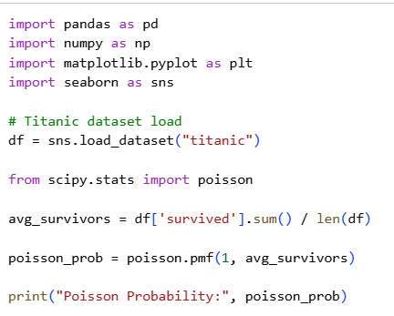
Output
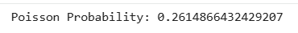
Result
The Poisson Distribution was successfully implemented to calculate the probability of observing exactly one event. The obtained probability was approximately 0.2615 (26.15%), demonstrating the use of Poisson distribution for modeling count-based events occurring within a fixed interval.

Ex. No: 08 | Correlation Analysis Between Numerical Variables

Aim
To analyze the correlation between numerical variables in the Titanic dataset and visualize their relationships using a correlation matrix and heatmap.

Procedure
- Import the required libraries (Pandas, NumPy, Matplotlib, Seaborn).
- Load the Titanic dataset using Seaborn.
- Select numerical variables (age, fare, sibsp, parch).
- Calculate the correlation matrix using the corr() function.
- Display the correlation values.
- Visualize the correlation matrix using a heatmap.

Program
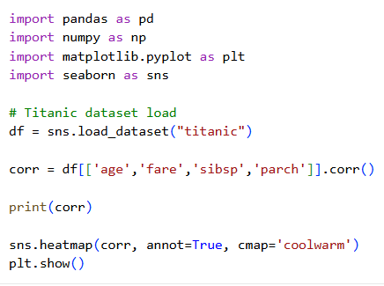

Output
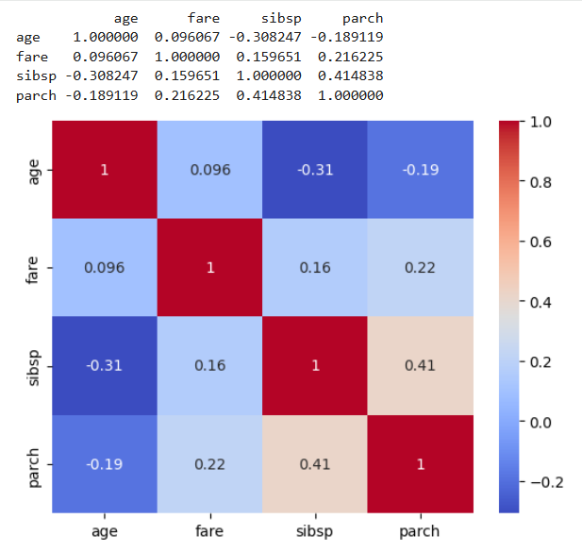
Result
The correlation matrix and heatmap were successfully generated for the selected numerical variables. The analysis showed a moderate positive correlation between sibsp and parch, while other variables exhibited weak positive or negative correlations, helping to understand relationships within the dataset.

Ex. No: 09 | Covariance Analysis and Interpretation

Aim
To calculate and analyze the covariance between numerical variables in the Titanic dataset and understand the direction of their relationship.

Procedure
- Import the required libraries (Pandas, NumPy, Matplotlib, Seaborn).
- Load the Titanic dataset using Seaborn.
- Select the numerical variables age and fare.
- Remove missing values using dropna().
- Calculate the covariance matrix using the cov() function.
- Display and interpret the covariance values.

Program
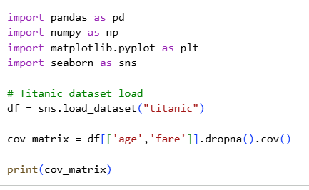
Output
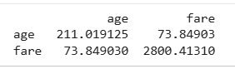
Result
The covariance matrix was successfully calculated for the variables age and fare. The positive covariance value (73.85) indicates a positive relationship between age and fare, suggesting that passengers with higher ages tended to pay slightly higher fares, although the relationship is not very strong.
Ex. No: 10 | Hypothesis Testing Using Z-Test and T-Test

Aim
To perform hypothesis testing using a T-test and determine whether there is a significant difference in ticket fares paid by male and female passengers in the Titanic dataset.

Procedure
- Import the required libraries and the ttest_ind function from SciPy.
- Load the Titanic dataset using Seaborn.
- Separate fare data for male and female passengers.
- Perform an independent two-sample T-test.
- Obtain the T-statistic and P-value.
- Interpret the result based on the significance level.

Program
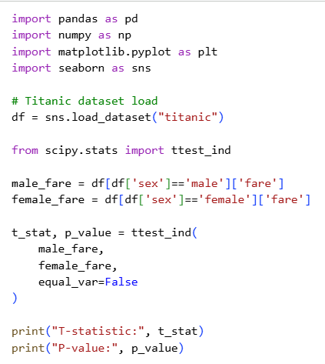
Output
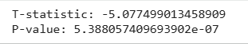

Result
The independent T-test was successfully performed on male and female passenger fares. Since the P-value is less than 0.05, the null hypothesis is rejected, indicating a statistically significant difference between the average fares paid by male and female passengers in the Titanic dataset.

Ex. No: 11 | Confidence Interval Estimation for Population Mean

Aim
To estimate the 95% confidence interval for the mean age of passengers in the Titanic dataset using statistical methods.

Procedure
- Import the required libraries and the normal distribution function from SciPy.
- Load the Titanic dataset using Seaborn.
- Extract the Age column and remove missing values.
- Calculate the sample mean, standard deviation, and sample size.
- Compute the margin of error for a 95% confidence level.
- Calculate the lower and upper confidence limits.
- Display the confidence interval.

Program
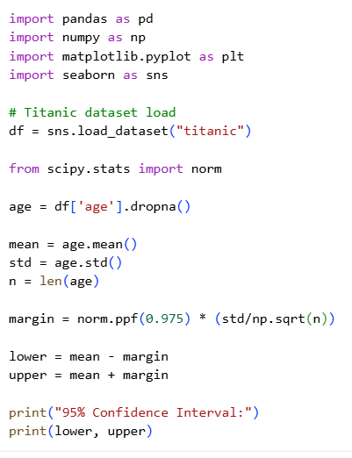

Output
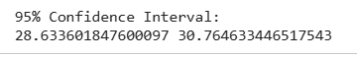
Result
The 95% confidence interval for the mean age of Titanic passengers was successfully calculated. The analysis indicates that the true population mean age is likely to lie between 28.63 years and 30.77 years with 95% confidence.

Ex. No: 12 | Univariate Exploratory Data Analysis

Aim
To perform Univariate Exploratory Data Analysis (EDA) on the Fare variable of the Titanic dataset using visualization techniques.

Procedure
- Import the required libraries (Pandas, NumPy, Matplotlib, Seaborn).
- Load the Titanic dataset using Seaborn.
- Create a histogram with a KDE curve to examine the distribution of fare values.
- Generate a boxplot to identify outliers in the fare variable.
- Analyze the distribution and spread of the data.

Program
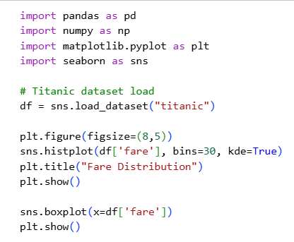

Output
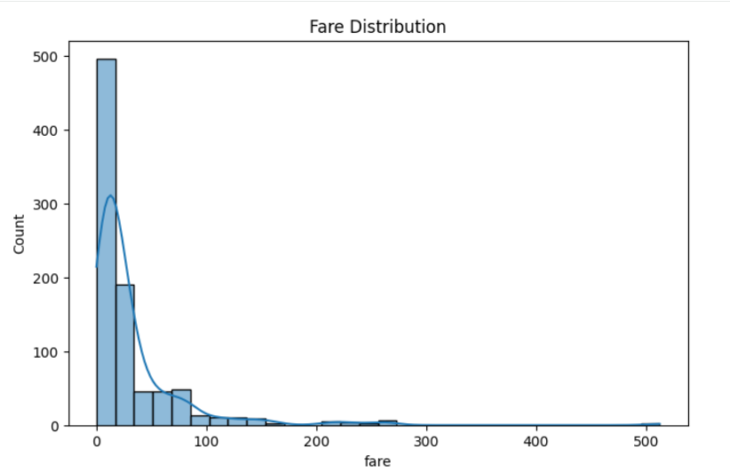
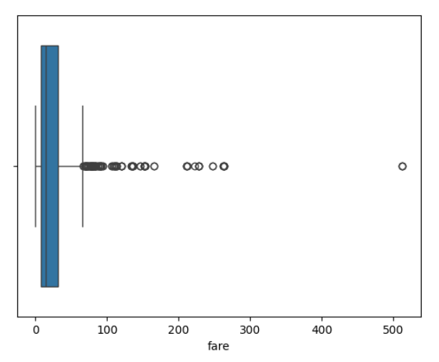
Result
Univariate EDA was successfully performed on the Fare variable. The analysis showed that the fare distribution is positively skewed, with most passengers paying lower fares and a few passengers paying very high fares. The boxplot also revealed the presence of several outliers in the dataset.
Ex. No: 12 | Univariate Exploratory Data Analysis

Aim
To perform Bivariate and Multivariate Exploratory Data Analysis (EDA) on the Titanic dataset and understand the relationships between multiple variables using visualizations.

Procedure
- Import the required libraries (Pandas, NumPy, Matplotlib, Seaborn).
- Load the Titanic dataset using Seaborn.
- Create a scatter plot to analyze the relationship between Age and Fare, with survival status as a category.
- Generate a pair plot for selected variables (age, fare, pclass, survived).
- Observe patterns, trends, and relationships among variables.

Program
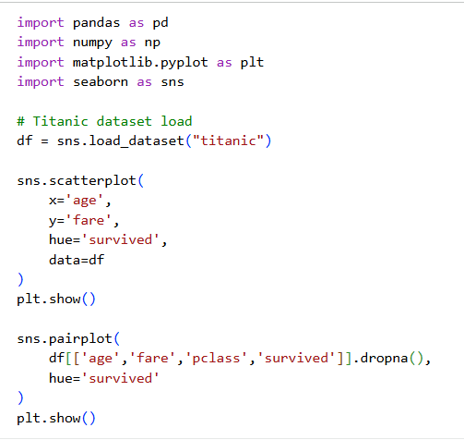

Output
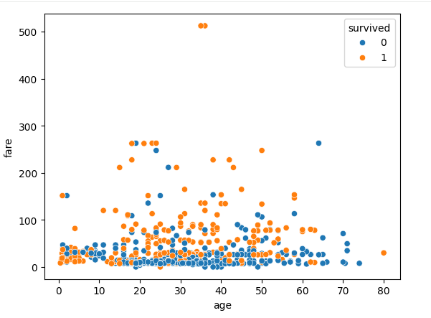
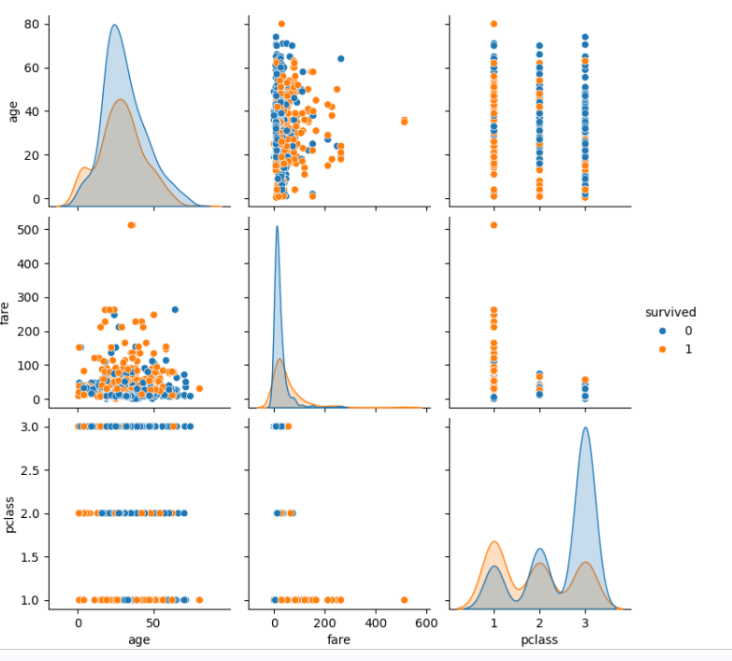

Result
Result
Bivariate and Multivariate EDA were successfully performed on the Titanic dataset. The visualizations revealed relationships among age, fare, passenger class, and survival status. The analysis indicated that passengers paying higher fares and traveling in higher classes generally had a greater likelihood of survival.

Ex. No: 12 | Univariate Exploratory Data Analysis

Aim
To perform a complete Exploratory Data Analysis (EDA) on the Titanic dataset by examining data structure, missing values, correlations, and relationships between important variables using statistical summaries and visualizations.

Procedure
- Import the required libraries (Pandas, NumPy, Matplotlib, Seaborn).
- Load the Titanic dataset using Seaborn.
- Display the dataset shape and identify missing values.
- Generate the correlation matrix for numerical variables.
- Visualize correlations using a heatmap.
- Analyze survival rates based on gender using a count plot.
- Examine fare distributions across passenger classes using a boxplot.
- Interpret findings and summarize key insights.

Program
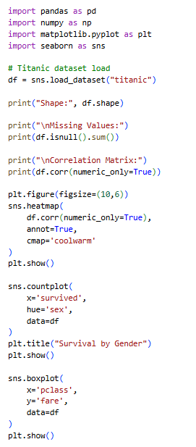

Output
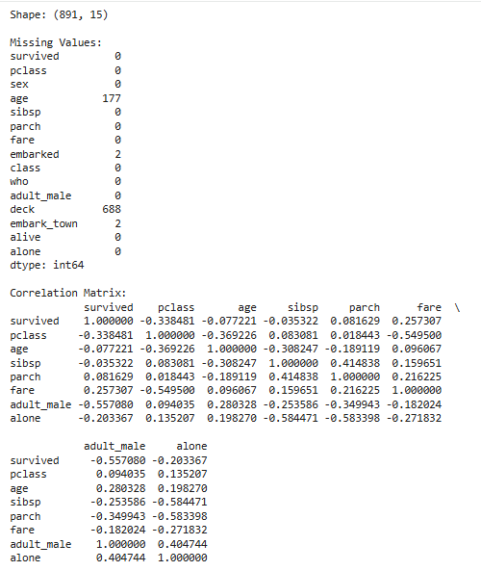
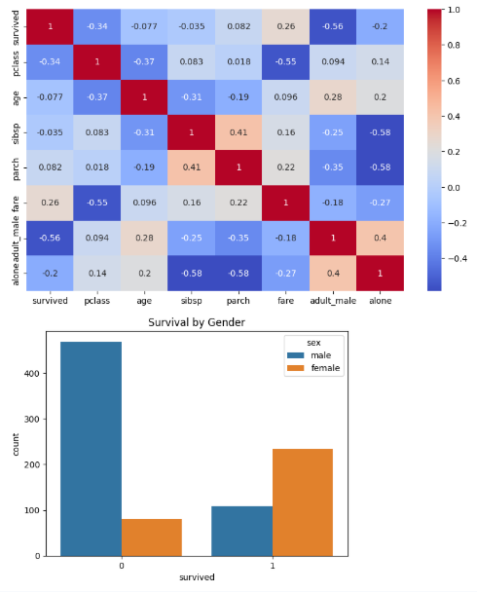
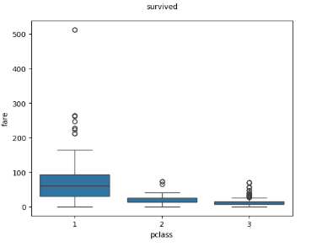
Result
A complete Exploratory Data Analysis (EDA) was successfully performed on the Titanic dataset. The analysis identified missing values, examined correlations among numerical variables, and explored relationships between survival, gender, passenger class, and fare. The visualizations revealed important patterns, including higher survival rates among females and differences in fare distributions across passenger classes.

